RESOLUTION NO.__________

RE: CERTIFICATE OF APPROPRIATENESS UNDER THE
PROVISIONS OF THE ACT OF THE PENNSYLVANIA
LEGISLATURE 1961, JUNE 13, P.L. 282 (53
SECTION 8004) AND BETHLEHEM ORDINANCE NO.
3952 AS AMENDED.

The applicant proposes to remove and replace the existing fence at 51 E. Wall St.

NOW, THEREFORE, BE IT RESOLVED by the Council of the City of Bethlehem that a Certificate of Appropriateness is hereby granted for the proposal.

Sponsored by: (s)

(s)

ADOPTED BY COUNCIL THIS DAY OF

(s)
President of Council

ATTEST:

(s)
City Clerk

HISTORICAL & ARCHITECTURAL REVIEW BOARD

The applicant proposes to remove and replace the existing fence at
51 E. Wall St.

APPLICATION #5:

R. Vidoni & B. Careyva
51 E. Wall St.
Bethlehem, PA 18018

OWNER:

__________________________________________________________________________

The Board upon motion by Phil Roeder and seconded by Connie Glagola adopted the proposal that City Council issue a Certificate of Appropriateness for the following:

- The stockade fence to be replaced with a wooden fence.

2. Color, details and copper post to match wooden fence at 57 E. Wall St.

3. The motion was unanimously approved.

__________________________________________________________________________

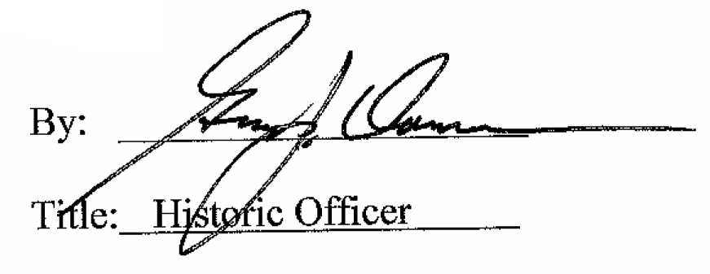

Date of Meeting: July 11, 2018

